World War I Webquest
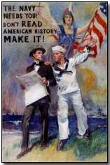
Historical Context:
World War I was supposed to be the war that ended all wars. Instead it set the stage for future conflicts throughout the 20th Century. The people of the time called the conflict the Great War, and they believed that there would never again be another like it. Although the United States tried to remain neutral, it was eventually drawn into the conflict. The war had a profound effect on the nation, and touched upon many aspects of American life. When the war ended, the United States, and the world, was changed forever.
Your Task: Place all of your answers on a separate sheet of paper for the following questions. Please use the links provided, powerpoints on webpage and your textbook to answer the following:

Area 1 : Choosing sides and war plans:
1. Using the map on page 389 (inclusion classes) and 412 (honors classes) in your textbook
-Allied Powers (6 major countries) -Central Powers (4 major countries)
-Neutrals (6 major countries)
-What were the central and the allies called before the war?
2. Which side did the United States eventually join? Why?
3. Which country switched sides just before the war started? Why?
4. List and describe the five long term causes of World War I. (Hint look at the MANIA ON PowerPoint 12.1 ww1 on weebly website)

5. What was the spark that led to the immediate cause of World War I?
(see link http://www.firstworldwar.com/origins/causes.htm)
6. Who was General Schlieffen, and what was his plan for World War I? What was his country trying to avoid by implementing this plan?

Area 2 : Weapons of War:
1) List and describe 4 weapons introduced in World War I. Be sure to explain their effectiveness and how they were used?
2) What is Propaganda? What were four reasons propaganda posters were used?
3) What nation produced the most posters throughout WWI?

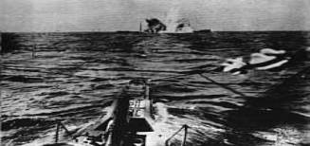

Area 3: Life in the Trenches:
1) What is trench foot? What caused trench foot?
2) What affects did it have on the body? What was the remedy for it?
3) Read the diary entries from Thomas Fredrick Littler and answer the following:
- Describe some common repetitive themes (tasks) of trench life.
- Define stalemate, How does the definition of this word describe life in the trenches?
4) What was No Man's Land? (Please be sure to describe at least three distinct features)
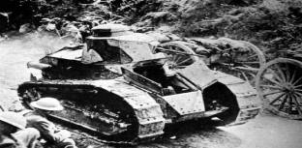
Area 4: America enters the War:
1) What was the Lusitania? What is the significance of the Lusitania in the War? How many people died and were there any Americans on board?
2) How many Allied and Neutral ships were lost to submarines in 1917? How many total number of Allied and Neutral ships were sunk by submarines between 1914-1918? (Scroll down...it's there!)
3) What is the Zimmerman Telegram and who wrote it? Why did Americans feel threatened by this telegram? (Think Monroe Doctrine).
4) In the telegram, what did the German government decide to begin on Feb. 1, 1917? What was promised to Mexico in the telegram?
5) When does the Untied States declare war on Germany? Who was John J. Pershing?
6) What was the Brest-Litovsk Treaty? How did it affect the fighting on the Western Front? (Think Schlieffen Plan)
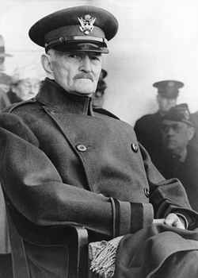

Area 5: Results of the War:
1) What was the name of President Wilson’s plan for peace? (hint see PowerPoint 12.4 ww1 on weebly website)
2) What treaty do the big 4 nations agree with? (hint see PowerPoint 12.4 ww1 on weebly website)

3) In Articles 231&232 of the Treaty of Versailles, what is Germany responsible for?
4) What country lost the most soldiers, and has the most missing, How many American soldiers died and what was the total number of soldiers who died in the war?
7) When did the war end? When was the Treaty of Versailles signed? Why are these dates significant?

